***Project Plan***

*Project Description*

*Scope, objective and goals*

The goals in this project include:

* Making a 2D platforming game with a broad end user group, which can be enjoyed by most people
* Creating a fully functioning character which can move in all directions as well as teleport
* Creating at least one enemy which is independent of the player’s movement and uses recursion.
* Designing and implementing an appropriate user interface
* Designing a code to interface with files on client computers
* Designing at least one 2D array/array of records
* Creating a full tutorial explaining the game’s dynamics
* Designing and implementing one or more levels/puzzles

The goal of this project is not for the game to seem ‘finished’, as there is simply not enough time for the project to be polished by the end of the year. If there was an extra year to complete the project, it may be more polished and able to be published. However, the aim of this specific project is to create a taster product rather than a finished and polished one. As well as this, this must be achieved through methods with meet the SQA Advanced Higher Standards as well as satisfying End User needs.*

As stated before there are no obstacles in meeting these goals apart from timeframe, as we have the full software to create a 2D platforming game.

*The methods with which we satisfy these needs are specified within the Project Proposal ‘scope’ section.

*Assumptions*

There are a few assumptions made in the planning of this project. One of these assumptions is that the software and hardware that are being used in the creation of the project will not malfunction throughout the project. As well as this, there is an assumption that if the person (i.e the SQA candidate) conducting this project gets sick or otherwise incapacitated, they will be able to catch up with their work before the deadline.

*Constraints*

The first obvious constraint imposed by the SQA is the constraint of a timeframe. The project must be completed by 19/04/2019, which only gives developers around 10 months to complete the project given. The project will most likely be completed by then but it is a small amount of time to complete a computing project. There are no constraints on length of project or documentation thereof, however the money spent on the project must be kept to a minimum as the project is being funded by an educational institution and needlessly spending is not an option. Despite this, the resources that are already available are sufficient to complete the project as the developer has a pre-existing license to development software, as well as any other software needed throughout the project. The only resource that may be limited is the time of the developer, as there is a limited amount of time they can spend on the project per week. Although flexible, the amount of time spent on the project per week will most likely be between 8-10 hours on holidays and between 10-11 hours during term time.

*Methodology/Life Cycle*

*SDLC (Software Development Life Cycle)*

Theoretically, the SDLC of this project should be a linear cycle as opposed to a recurring one, which means that the project will be completed stage by stage then once all stages have been completed, a review of all previous stages will be conducted and any changes needed will be implemented. This will follow the typical Waterfall model (i.e Analysis, Design, Implementation, Testing, Documentation, Evaluation, Maintenance) as opposed to the Rapid Application Design method which is becoming increasingly popular. The project will follow the waterfall method as it makes more sense within the time frame we are provided with and the company we are providing the software for (i.e the SQA).

Despite the theory of the SDLC of this project, it is likely that at each stage, the previous stages will be reviewed and changed throughout the project, making it more recurrent than linear.

*Work Breakdown Structure*

A work breakdown structure for this project is not required as there is only one person developing the project, therefore rendering a WBS meaningless.

*Resources*

There are very little resources to manage as there is only one person developing the project. Therefore types of labour and various sections of labour do not need to be assigned and instead are all given to one person (the developer/SQA candidate). As for the resources unrelated to labour, throughout the project the developer will require access to a computer with the capacity to run a 2D game and store a small array of levels, as well as word processing and game development software. All of which there is easy access to. Although it is preferable to have access to an educational institution, it is not required to complete the project. However, unless there is a drastic change it is likely that most of this project will be carried out within the grounds of Wallace High School, where the institution’s facilities will be given freely in order to ensure the completion of this project. Other than this there are little to no resources required to complete this project.

*Schedule*

All activities within the project are stated in the project proposal. The activities and the timing of said activities are stated below.

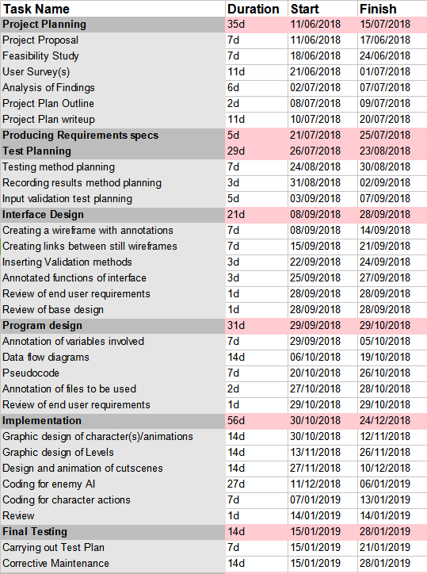

Milestones for the project are stated in bold above and the completion of each milestone will mark another section of the project completed.

*Documentation*

Documentation of activities and quality of work will be carried out throughout the project via a spreadsheet which includes the quality, length and details of work within a particular session. Within every session, the details of said work session should and will be recorded. A template will also be made and used for the debugging of the end product, where bugs and solutions for those bugs will be recorded.

*Risk management*

*Possible risks:*

* *Risk of not finishing project in time*
* *Project not living up to SQA standards (resulting in a poor completion of project goals)*
* *Project not living up to personal standards (resulting in poor completion of project goals)*
* *Project not being compatible across different versions of windows*

Out of these risks the most important to avoid are the projects not living up to SQA and personal standards, as a vital goal of this project is to create a game which is examinable and enjoyable.

*Risk Triggers:*

* Becoming behind on certain activities
* Not paying attention to SQA guidance
* Forgetting original goals
* Forgetting to code for certain goals

*Preventative measures:*

* Continuously refer back to SQA guidance throughout the project
* Continuously refer back to project plan and proposal throughout project
* Check in with main goals after implementation and planning

*Risk resolution*:

* If the developer becomes behind on certain activities, move the approximate 10hrs of work/week to 12hrs of work/week and only have the developer work alone until caught up
* If the developer forgets to implement certain goals, they must go back to the area that is unfinished immediately and finish the area or arrange time in which to finish the unfinished work. If this results in the developer being behind on work see above risk resolution.

*Responsibility*

All responsibility for the project is placed upon the SQA candidate/ developer meaning that if the project fails or does not meet all goals then the blame is placed upon the developer. This also means that the developer is the only person to carry out the above precautions and resolutions should the need arise.

*Quality assurance*

Once again the fact that this project is only being carried out by one developer is important as this also means that this developer will be carrying out quality assurance. In order to ensure the quality of the end product, the developer must have access to a PC with Windows 7 and a PC Windows 10. This will ensure compatibility across all versions of Windows. Both PCs are available to the developer either through Wallace High School or personal means. As well as this, the developer must have access to a word processing programme, a game-making/sprite-making programme and a object oriented coding environment (e.g. Python or GameMaker Studio).

A feedback loop must also be put in place in order to ensure the quality of the project. This means that throughout the project the developer will ask for feedback on the project from the target audience at the end of each stage of development and make justified changes based on this. This will ensure the quality of the end product that will be handed into the SQA, as well as ensure the end goal of this game being both examinable and enjoyable.

*Monitoring, approvals and tracking*

In order to track progress and upcoming deadlines, an online app called ‘trello’ will be used. This creates a project board as well as checklists and deadlines to track upcoming events. This will ensure that the project is tracked effectively and therefore deadlines aren’t missed.

As stated before, the project will be monitored by a record of progress and reflective comments written on said record of progress.

The only approvals needed for this project is that of a representative from Wallace High School (Stuart Winton), which has been obtained via. Email after sending the project proposal and receiving approval to continue with the project.

We are aiming for this project to be completed by the SQA deadline as a taster for a full game.